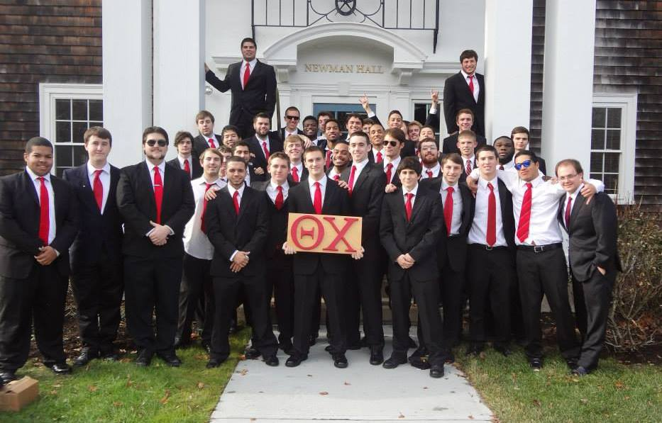 |  | Theta Chi  - Eta  - Alumni Newsletter

Eta Chapter Involvement Around Campus
As the semester progresses our involvement around campus has continued to grow. This past weekend we sent four teams to Alpha Xi Delta’s “Xi Marks the Spot” charity event, where four of our newest pledges, Mike Galasso, Brian Hopkins, and Tanner Maurice placed third amongst all Greek life.
In addition to that we have also made our mark around campus in different ways. This past weekend we also had a group of guys run the 5k-race fundraiser around campus. We raised $430.00 as a chapter through this race, and later on that day we took part in Relay for life were we raised $470.00.
We also have been holding events ourselves as well. Philanthropy chairs Mikhail Hyde and Joe Grenier have organized booths on multiple occasions.
For example this Friday (April 3) we will be holding the first G.I Theta Chi booth on the quad to support the troops overseas. Here we will be handing out T-shirts, water bottles, and other giveaways as we take in donations to help support the troops overseas.
We like to pride ourselves in exemplifying the values in the Theta Chi creed. We extend the helping hand to all who seek it here at URI and in the surrounding communities.

Chance to reconnect with past brothers, meet new brothers

The Theta Chi alumni barbeque will be held on April 25th at 55 Lake Rd in Narragansett, RI. Here past and current brothers of our great Theta Chi Fraternity will be able to catch up and share old and new memories.

Also Greek Week is approaching within the coming weeks. This means Lambda Chi’s Alumni Softball game is right around the corner (April 11th). If you have not yet contacted Chris Lawlor, and are interested in playing for team Theta Chi, then you can contact him at clawlor549@my.uri.edu.

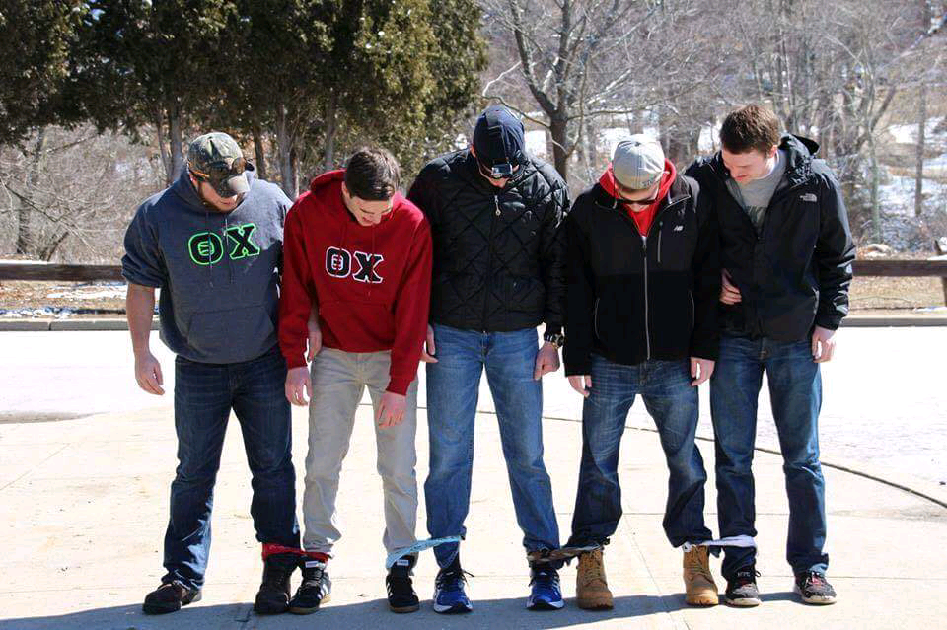

Some brothers participating in Alpha Xi Delta’s “Xi Marks the Spot” scavenger hunt

Brother Spotlight: Adam Franklin:

Adam Franklin is 1st year student at the University of Rhode Island from Boonton Township, New Jersey. He is a 400-meter runner on the track and field team, but is very much committed to fraternity related events. Rushing in the fall semester, Adam was not sure if he wanted to join a fraternity. But after meeting the guys of Theta Chi and learning more about their ideals he knew that joining was a smart move. "Every brother of Theta Chi is more than just a brother, but a friend that you can go to with advice and personal issues." For Adam, joining Theta Chi opened up a whole new perspective on the university and Greek life for the better.

URI’s Greek of the Week:

Theta Chi’s own Brandon Sousa was named “Greek of the Week” here at URI during the week of February 20th, for his contribution to not only his fraternity but also his campus as a whole. Brandon is a senior who helps us out a lot as a fraternity and is a good mentor for the younger brothers as they develop into bringing this fraternity to the top. With that said he still finds the time to help the community around him. He is an orientation leader and also a Butterfield Hall RA, and is a student organization leadership consultant. Brandon is a double major in biology and psychology, and minors in sociology, chemistry, and leadership studies. He made the deans list last semester with a 4.0 GPA. Congrats Brandon you showed what Theta Chi material is all about!

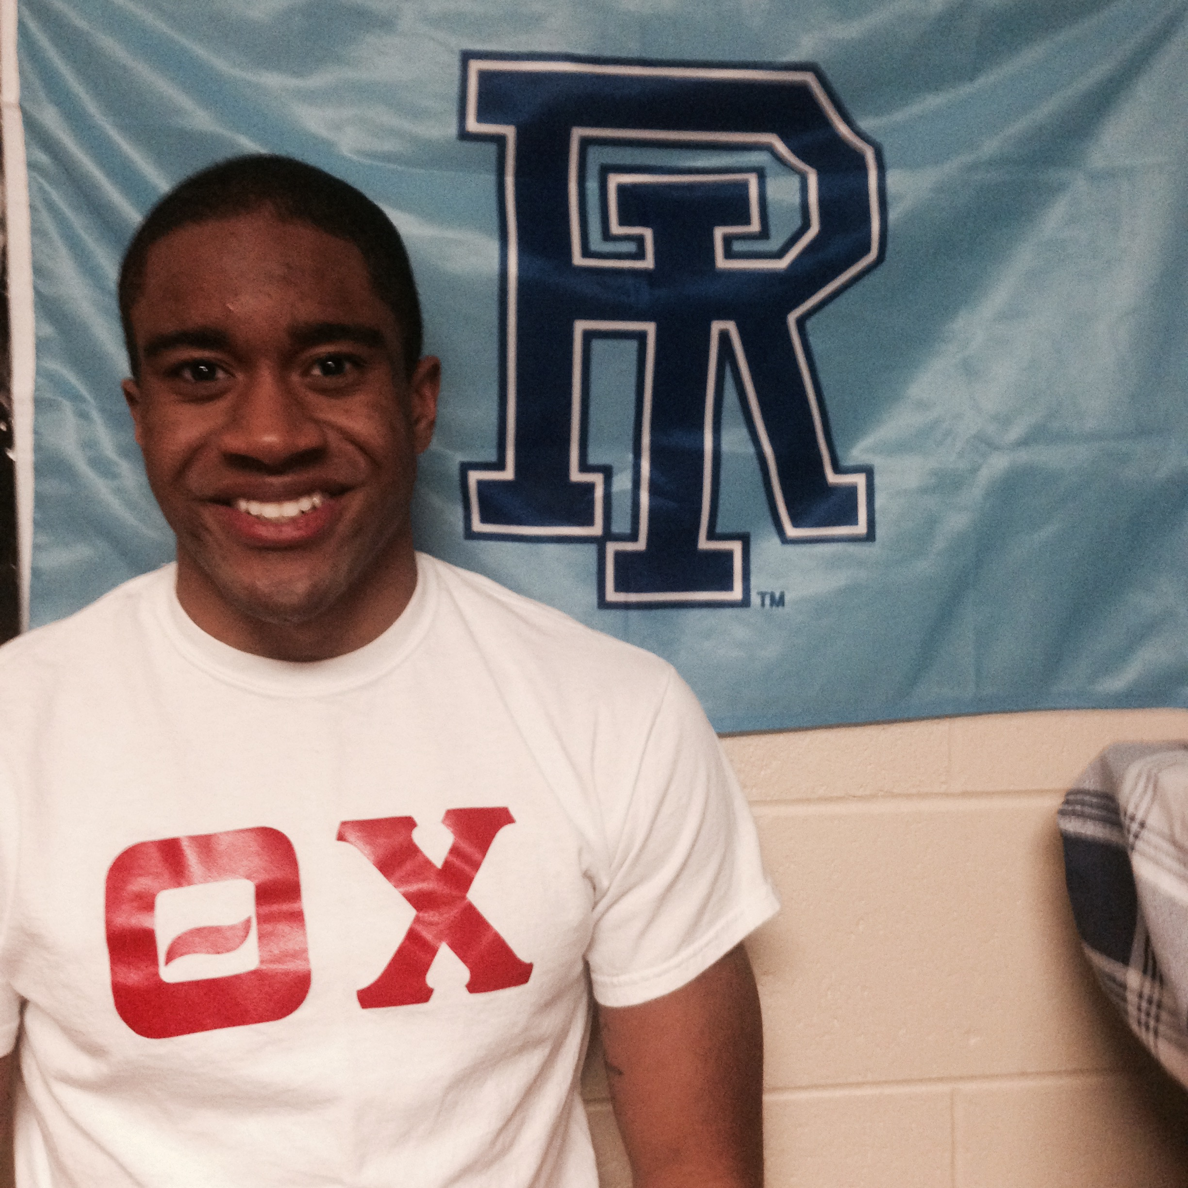

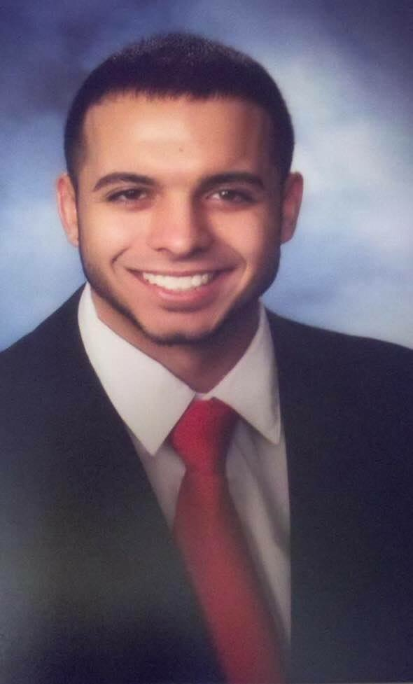

A Big Thank you Goes out to the following Alumni for their donations to Theta Chi Eta Chapter to our general fund:
Henry Capuano
Jerry Ricciardo
If you would be able to extend the helping hand to your fellow brothers, Eta Chapter would be incredibly grateful in helping us bring this chapter to the absolute best it can be.
Please visit: www.gofundme.com/nhf8vw

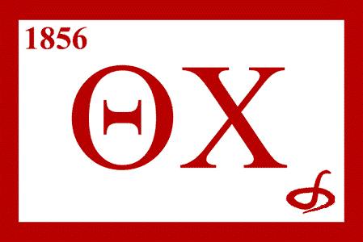

Created by:
Dan Finan & Nick Thomas
Alumni Relations Chairman
Daniel_finan@my.uri.edu Nicholas_thomas@my.uri.edu

