PART 1 - Overview
Industries and companies all around the world continue to find new ways to increase consumer interest. Whether it’s the Smokey the Bear campaign to raise awareness of the dangers of fire or Daren the Lion of D.A.R.E. promoting drug awareness, industries always work to find a campaign that consumers can get behind and truly believe in. The “Got Milk?” campaign was no different. Consumers everywhere are familiar with the famous milk mustache imprinted on all of their favorite athletes and celebrities. However, the “Got Milk?” campaign became so widely popular so rapidly that it begs the question “Why was it needed in the first place”. With these posters plastered all over cafeterias, schools, and doctors/dentists offices it seemed as though it was a campaign that people everywhere couldn’t seem to escape. Although, to realize how this idea became such an effective, award-winning campaign, one must realize; the needs of the milk industry and the strategies utilized by the public relations agency running the show.
The “Got Milk?” campaign all comes down to the simple question; what were the needs of the milk industry. The milk industry began to see a decrease in the amount of people who were buying and drinking milk in the middle of the 1990’s. A large part of this was due to the introduction to new drinks. Pepsi and Coca-Cola (and then other soft drink companies) began making a splash in the beverage market in the 1960’s and 70’s, which was then followed by improved juices, energy drinks, and iced tea drinks. This new line of drinks (large part of them readily available in stores) caused the milk consumption to decrease. With that said, the main point of this campaign was to get people to drink more milk and less of the other drinks in the market. The milk market found itself in a trench trying to compete with powerful advertisements from brands such as Pepsi and Coca-Cola.
As this trend continued, the California Milk Processor Board (CMPB), who pride themselves on spreading the word about products with real California milk, began to look for ideas to compete with new, enticing drinks within the market. Their main focus was in trying to get all those consumers that they lost back to buying their product. It wasn’t until they brought along the marketing agency Goodby Silverstein and Partners (GS&P) that they figured out their new plan. When GSP began working on a way to get California Processor Board’s milk in all the households that had stopped drinking milk they formed focus groups, however were not able to immediately come up with anything. “It’s perhaps the most boring product imaginable”, said Jeff Goodby (of GS&P) in an article he wrote commemorating the campaign 20 years later.
The above quote shows the mindset and adversity that this agency faced when given this product and asked to pitch it. According to Goodby, his co-workers, Jon Steel and Carol Rankin were working in one of the focus groups, when they over heard someone say, “The only time I even think of milk is when I run out”. Additionally they summed together the idea that “milk is usually consumed with something else”. It was from that moment on that Goodby scribbled “Got Milk?” on a poster board.
As previously mentioned, this campaign began to focus not on the consumers who stopped drinking milk, but the ones who continued to drink milk throughout the drop in milk consumption. Although this campaign obviously became national and even international, at the time GS&P was only focusing on loss of consumers that the California Processor Board faced. So, it was only the consumers of the CMPB milk in which they originally targeted. However, it took strategic ideas to figure out how to figure out who their target audience was.
GS&P wanted to reach out to the community to figure out what they wanted. Not only did this establish a sense of care for the consumers, but allowed GS&P to gain extremely valuable information as to what consumers would like to see, taste, and hear. GS&P conducted a telephone survey in which they surveyed a small representation of the California population as a whole (used ratios). In addition to the telephone survey they also held public focus groups in which they invited the consumers. These focus groups also included interviews, establishing face-to-face relationship between the minds behind the product and the audience.
Additionally, not only did GS&P use interaction with their consumers as an effective observation, but they also used other research methods. For example, they used national Neilson household panel. According to Neilson, panel information gives demographic data of a buyer, where they buy it from, how often they buy it, other interests, and even how loyal they are to the products they buy. This was an obvious tool that GS&P used to support their research in California. Not only where they able to see what demographic areas consumed the most milk, but they were able to see which areas/households decreased their consumption of milk and moved onto other products such as soda, juices, and coffee. Additionally, they were able to see not only the area in which this happened, but also the exact grocery (convenient store/etc.) store it took place in.
The deprivation theory was an underlying factor in successfully targeting a large target audience. Health has always been considered a “movement”. Meaning people are always trying to encourage others to be healthy, mainly by eating better and staying active. In regards to the situation that GS&P as well as the CMPB found themselves in, they were able to use that as an advantage. For example, if they were having trouble selling something along the lines of an alcoholic beverage such as beer. Beer is not good for ones health, and additionally has to compete with already successful products such as Budweiser, Corona, etc. Furthermore, if a beer brand can’t sell based off of the realization that it can’t compete with the stronger, more popular products in that market, than it doesn’t give consumers any reason to want it (because it is unhealthy and simply not as enjoyable as the better products).
With that said, milk is obviously a much healthier choice than beer. As mentioned earlier, the main reason that the California Milk Processor Board asked Goodby Silverstein and Partners for help pitching their product was because there was a higher interest in other products, such as juices (Arizona Iced Teas, for example), coffee and energy drinks, and other sugary drinks. By promoting the healthy perks of drinking milk (high calcium, keeps bones strong, etc.) they are also endorsing a healthy way to live, and that they are interested in the consumer’s well-being and health. In other words, the California Milk Processor Board (CMPB) possess (sell) a healthy drink in which the consumers should possess (buy) as well.
Furthermore, after working together through this research, CMPB and GS&P were able to put out a commercial titled “Aaron Burr” (third vice president of the United States). This ad features a history scholar, someone who is often seen as smart, losing a trivia contest because he was unable to speak. Why? Because he had a mouthful of peanut butter with nothing to wash it down. In addition, they ended the commercial with the words “Got Milk?” This goes back to the previous idea that GS&P built this campaign on, “The only time I even think of milk is when I run out”. Eventually a national program called The Milk Processor Education Program (MilkPEP) picked up this campaign. It is nationally funded by the nations milk processors (such as CMPB) and mirrors the mission and goals of CMPB of increasing consumers’ health through milk consumption (another example of where the deprivation theory comes in with this campaign).
PART 2 – Data Analysis
The forces behind this campaign that drove it to be successful was not only CMPB and GS&P’s efforts, but also knowing the percentages by doing research. CMPB conducted a survey where 70 percent of people in California drank milk meaning only 30 percent did not. As mentioned earlier in part 1, it wasn’t until the GS&P was hired when CMPB realized that they were going about their advertising wrong the whole time (catering to the wrong percentage). While a loss of 30 percent is significant, a consumer market of 70 percent is even more promising. Additionally, instead of trying to keep that substantial 70 percent highly engaged and interested with their product, they were trying to get that 30 percent of consumers back. This is when they began to target the customers that never left rather than the ones who started buying different drinks in the market. In addition they were also able to figure out that 88% of consumers who still bought and drank milk typically consumed it with other foods (chocolate, peanut butter and jelly, etc.)
The main idea behind this is that the research was the impetus for this campaign. Without the research, CMPB and GS&P would have kept advertising and pitching to the wrong percentage (that 30 percent). With that said the 70 percent who stayed could have become uninterested because the company in which they believe in (CMPB) wouldn’t seem to show them much attention or say things that they wanted to hear. Without the research, CMPB and GS&P wouldn’t have known whom to focus their campaign on.
In addition to the research, competition was another driving force that kept this campaign going. Pepsi drew advertising from (at the time) the largest ad agency Barton, Batten, Durstine, and Osborn Co. (BBDO) in which they had been going through a 500 million dollar campaign (“Generation Next”), while “Got Milk?” was a 23-million dollar campaign. Additionally, Snapple had a large fan base. Many of their ads at the time would feature “Snapple Lady” answering fans’ questions that they had sent in.
This put the “Got Milk” campaign in a tough situation because they had to continue to keep their name as relevant as Pepsi, without having nearly as much money to spend, but at the same time not lose the fan interaction that Snapple showed with their consumers. This allowed the “Got Milk?” to continue to get better and keep going.
This successful campaign did not just survive and thrive off of the behind the scene motivation and research work, however. From the moment the first ad of the “Got Milk?” campaign aired (“Aaron Burr”, pg. 4), they used the Tie-in method. Edward Berneys was the first to sway and manipulate the public’s mind by gather models together to smoke cigarettes for a photo shoot as they walk down 5th Avenue, a very populated area. Since the ad was for cigarettes this got the thought process going among females that they can smoke and still be beautiful (or maybe that they would become that beautiful). Goodby Silverstein and Partners used the same method here. They would use celebrities, all-star athletes, and rock stars as their poster boys, adding a white, milk mustache and simply asking viewers of the poster “Got Milk?” or encouraging them to “Drink more milk”.
Tom Brady (2002), Jessica Alba (2002), Hilary Duff (2003), and Tracy McGrady (2004) all are just a select few names that have famously worn the milk mustache on a “Got Milk?” ad. These athletes and celebrities’ own brands were both widely known both nationally and internationally. This contributed to how important it was for GS&P to get people not just nationally, but internationally popular. This is where Berney’s Tie-in method comes into effect. According to a CNN article from 2005 (full year after those 4 celebrities were on “Got Milk?” ads), there were an estimated 41 million kids (ages 6-13) in the United States who play competitive sports. When kids would eat lunch in the cafeteria, go to the dentist/doctors, or maybe in a food outlet of some sort, and look up and see their favorite athlete such as Tom Brady or Tracy McGrady, they begin to think “Maybe if I eat healthy and drink healthy [such as milk] I can be in their position some day. When girls see Jessica Alba and Hilary Duff on these ads they think, “If I drink healthy (milk) I can grow up to be as pretty as them”.
With this tactic used throughout the country, it begs the question; did it work? How did this campaign actually impact sales? According to the New Yorker, “Got Milk” didn’t actually get more people to buy more milk. The intake of milk and other dairy products has steadily declined from .96 cups in 1970 to .59 cups in 2011. Additionally, according to Gene Del Vecchio, in the year 1994 (full year after Got Milk was started) in California there was about a two percent increase in the total gallons throughout the year from the previous in 2013. However, Del Vecchio also stated that the yearly consumption of milk has declined from 23.9 gallons per person in 1995 to approximately 20 gallons per person in 2011. Overall, the numbers show a steady decline in milk consumption from around the time the campaign was made to around the time it changed (or in some people’s eyes, retired). Turning to page 12 will give a visual of the decline in milk consumption in the United States in a smaller sample size of the “Got Milk” Campaign.
Furthermore, according to the Neilson scanner testing, there was a seven percent increase over the course of the year (1993-1994) in the amount of milk consumption (about 40 gallons, 100-million dollars) in California households. However as the milk consumption increased in California, it decreased nationally.
Although this may come as a surprise that the numbers don’t align with the campaign as one would think, it is not purely the campaigns fault. There are a number of implications that interfere with the consumption of milk, the most notable of which being lactose intolerance (inability to fully digest sugar in dairy products). Mark Bittman of the New York Times said that within this country alone, about 50 million people are lactose intolerant, 90 percent of all Asian American, and 75 percent of all African-Americans and Jewish within the country. When putting this campaign to effect, it must be understood that while a significant percentage of these ethnicities can’t or don’t drink milk, does not mean that you should not target your campaign towards them as well. The 10 to 25 percent of these ethnicities that do consume milk can provide the campaign with diversity among the milk consumption in the United States. In addition, conditions such as acid reflux do not respond well to any dairy products, immediately leading to heartburn. Given those numbers, there are certain cultures in which seem to have more inability to drink milk. Additionally, Bittman talks about how milk is our number one source of saturated fat, which typically leads to type 1 diabetes. When considering these health concerns along with milk allergies and milk intolerance, the main focus for
Aside from these cultural health implications are the cultural belief implications. Animal cruelty is a topic that has grown amongst the country within the past twenty years. Approximately 9 million dairy cows are kept in captivity for milk (and other dairy) production, many of which are forced to live depressing and tortured lives. Given these cultural implications of different health concerns and topics, it may not be purely “Got Milk’s fault that the campaign did not sell as much as it believed it could have.
Although numbers may disagree with the actual success (on sales) of the “Got Milk” campaign, the idea that it was considered an award-winning campaign is undeniable. The “Got Milk?” campaign did not just make milk consumers go out and buy more milk from any brand. The success of the campaign directly imitated the success of CMPB. GS&P conducted a survey in 1999 in which they were able to summarize that the “Got Milk?” campaign was more widely known (greater) than campaigns of Pepsi, Gatorade, and Coke taglines. Additionally, CMPB did some more valuable research of their own and conducted an awareness survey in which they were able to report that the “Got Milk?” campaign had a 97 percent awareness rate in California. This was supported by the campaign eventually going on to win a David Ogilvy Research award as well as ADDY Awards.
Given the national recognition and awards that this campaign was given, why would it be redesigned to “Milk Life”? The main reason behind this was to remind consumers of the actual protein benefits of drinking milk. According to the U.S. Department of Agriculture milk consumption had dropped about 25 percent since 1975. As mentioned before the actual mission of the “Got Milk?” campaign was not a success by the numbers (in terms of increase consumers’ milk consumption). According to Julia Kadison, former interim CEO of MilkPEP, the redesign process was not in efforts to get rid of the “Got Milk?” campaign, but rather about trying to remind the consumers who have forgotten or never knew what the nutritional value in milk was. This being the case, “Milk Life” promotes the nutritional value of milk rather than the milk product as a whole. The main point behind the redesign was that consumers had forgot about milk, and needed to be reminded or educated about the nutritional value of it.
PART 3 – Analysis of Social Media in “Got Milk?” and “Milk Life”
Many aspects of life within the United States has change since the beginning of the “Got Milk?” campaign in 1993 to the redesign of “Milk Life” in 2014. For example, the world is digital now. With social medias such as Twitter, Facebook, and Instagram; news can break in a second, a company can advertise a product with the click of a button, and many more opportunities that were not around for a large portion of the “Got Milk?” campaign.
First, as an example, with the younger generation always being online an on social medias, Milk Life’s website provides a social media like community where consumers can share their stories. Here viewers can view recipes with the use of healthy milk, which itself is a marketing strategy. By showing different recipes and possibilities with using milk, consumers begin to realize that they don’t need to just drink milk directly to get the needed nutrient and proteins. Mentioned earlier, when Goodby Silverstein and Partners first began their research to pitch an idea for the “Got Milk” campaign, they observed that 88% of consumers wither use milk with something or use milk for something. Furthermore, the original research of the campaign (for Got Milk) was able to have an influence on this redesigning process, because when Milk Life began to look at their target audience, they were able to understand that most people enjoy milk when it’s not by itself. Consequently, by putting it on an easy to access place on their website, it makes it simpler for consumers to make it a part of their everyday life. For example, once people begin to use the Milk Life website everyday to see if there are any new recipes, stories, or tips, it becomes a part of their life.
Additionally, using Twitter and Instagram have also come into use for Milk Life. They use these social media platforms as a tool for customer/fan involvement, where they share recipes (EX: protein bar, how to use almonds in your diet, what to include in a breakfast, etc.) as well as “enter to win contests”, where fans can win culinary trips to places such as Los Angeles and New York City. Also, they can simply use their Twitter and Facebook to ask their followers/fans questions about their diet, such as: “What kind of milk do you drink? Doctors say it’s important to look at the big picture” (see figure 1.2, pg. 12 & 13 of tweet examples). By doing this over social media they are able to get immediate results and feedback from their followers, while at the same time showing them that they are always keeping their health and best interest in mind.
Additionally within many of their tweets, photos, and videos Milk Life contains links that will send consumers directly to an article. Within these articles, Milk Life can inform their followers about the health benefits such as the nutrients and protein found in milk. In addition, they can also include quotes, recommendations, and more from doctors to directly show the importance of milk consumption in their diet. This helps Milk Life successfully complete their mission of informing their consumers about the health benefits of milk. Having a trustworthy source such as a doctor can only lead to consumers having more trust and belief in the campaign. The Milk Life campaign used the deprivation theory as a role in this strategic tactic as well because it showed these consumers that they needed something that Milk Life possessed, for their own benefit and health. In the end, Milk Life is able to successfully use their own website along with social media platforms such as Twitter, Facebook and Instagram to keep their consumers engaged, but also informed on the health benefits of milk and why it is needed in someone’s diet; which was the whole purpose of the redesign process.
In conclusion, the “Got Milk?” campaign would not have had the national and international popularity success that it had without the strong marketing and advertising efforts of Goodby Silverstein and Partners (GS&P). The underlying use of the deprivation theory also played a large factor in making a smooth transition from the “Got Milk?” campaign to the “Milk Life”. The numbers of milk consumption may have decreased as a whole over the course of the campaign, however the illusion that this campaign was successful speaks volume to the work that GS&P put forth to market and advertise it. Ultimately, it was the research methods and observations of valuable data that GS&P conducted behind the scenes that drove this campaign to become as popular as it did.

Figure 1:

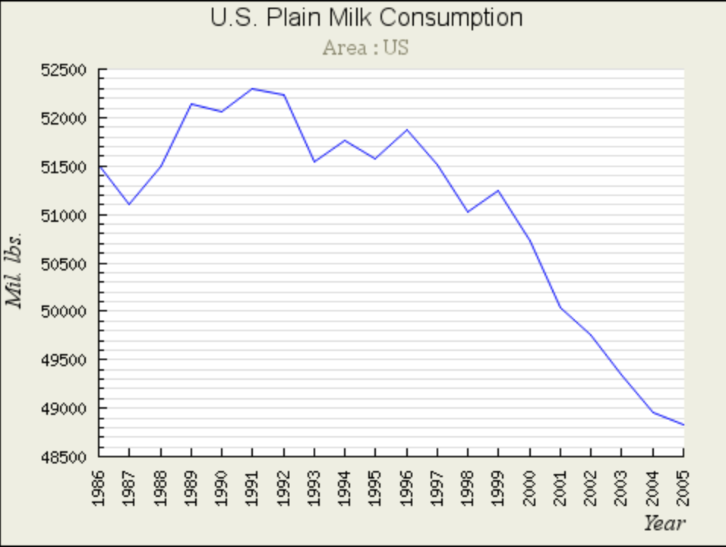**Notice the decreasing trend in milk consumption (in pounds) over the course of these years, 1994-2005 were during “Got Milk?” campaign** (graph via University of Wisconsin-Madison)

Figures 1.2:

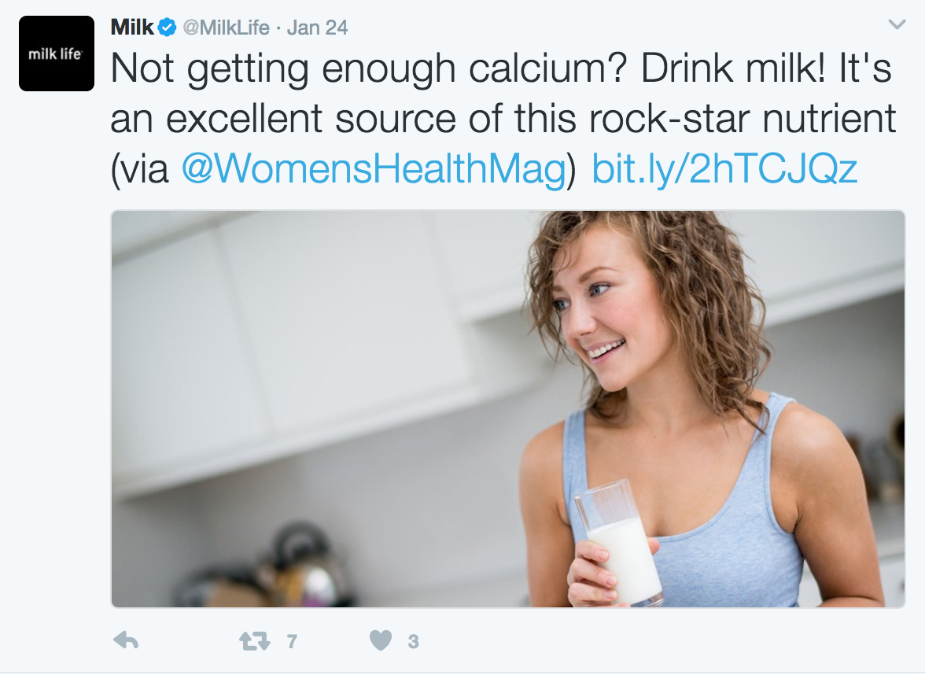
** Notice the article link included in the tweet
as well as engaging the followers with question
regarding health.

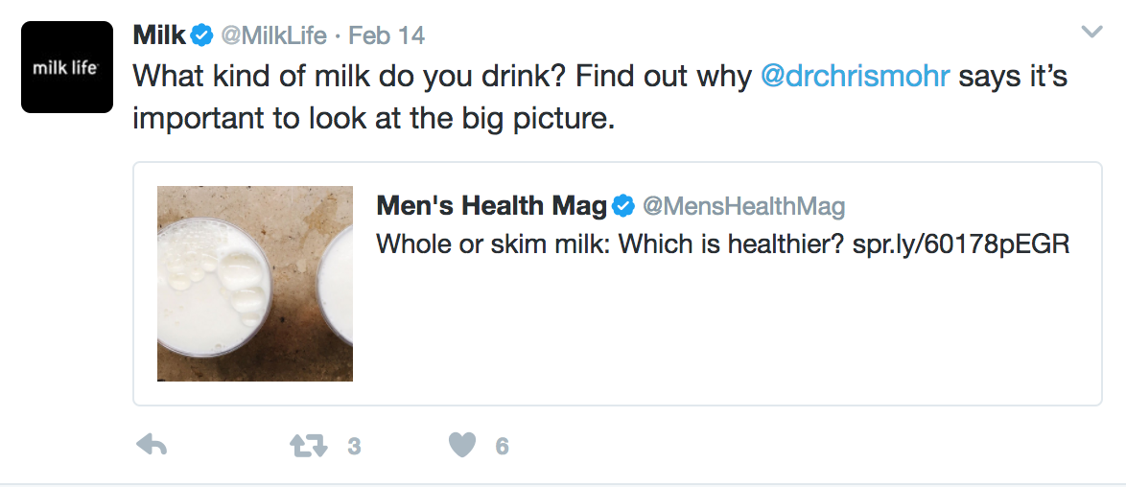
**Another tweet engaging the audience
and bringing in a credible source (doctor).
letting followers who haven’t read the article
know that a doctor’s expertise can be found.

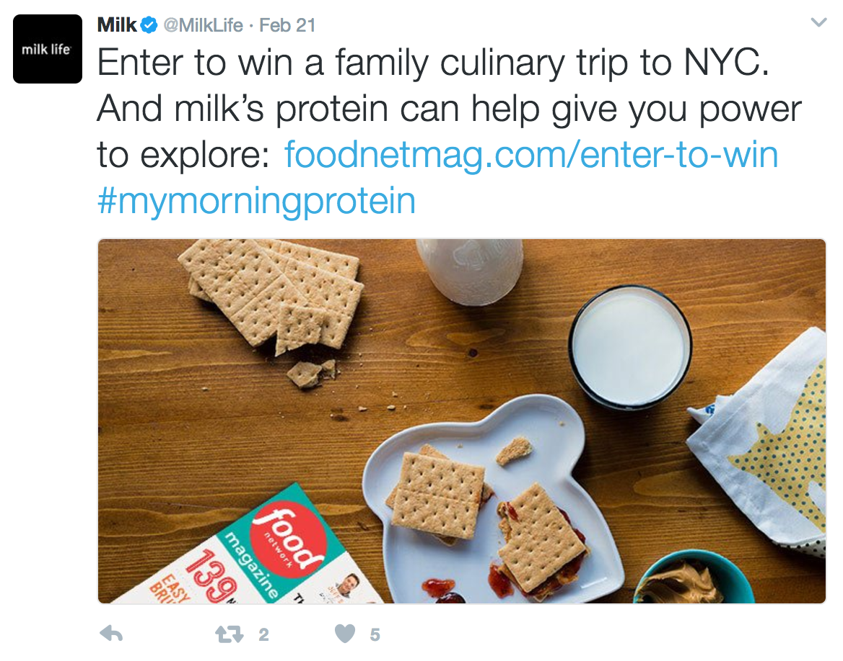
Another engaging tweet, offering an incentive to drinking milk,
but also a reason to want to read more into Milk Life.

Works Cited Page:
Goodby, Jeff. October. “20 Years of 'Got Milk?'.” Adweek, 25 Oct. 2013, Accessed 22 Feb. 2017.

Hilgers, Laura. “Youth Sports Drawing More than Ever”. CNN, Cable News Network, 5 July 2006. Accessed 22 Feb. 2017

"California Milk Processor Board" “Encyclopedia of Major Marketing Campaigns”. . Encyclopedia.com.21 Feb. 2017

Durando, Jessica. “'Milk Life' Replaces 'Got Milk?' Ad Campaign.” USA Today, Gannett Satellite Information Network, 24 Feb. 2014, Accessed 22 Feb. 2017.

Martin, Sally. “Household Panel: The Other Data.” CPG Data Tip Sheet, CPG Data , 10 June 2015. Accessed 22 Feb. 2017.

Keyes, Alexa. “‘Got Milk?" Not Anymore.” NBCNews, NBCUniversal News Group, 24 Feb. 2014. Accessed 22 Feb. 2017.

Bittman, Mark. “Got Milk? You Don't Need It.” The New York Times, The New York Times, 7 July 2012. Accessed 22 Feb. 2017.

Vecchio, Gene Del. “Got Milk? Got Fired: 5 Valuable Lessons That All Executives Must Heed.” The Huffington Post, The Huffington Post Edition US, 12 Mar. 2014. Accessed 22 Feb. 2017.

Kardashian, Kirk. “The End of Got Milk?” The New Yorker, The New Yorker, 28 Feb. 2014. Accessed 22 Feb. 2017.

“Milk Life Campaign.” Milk Life Campaign | International Dairy Foods Association. Accessed 22 Feb. 2017.

“Home.” Milk Recipes and Other Healthy Breakfast Ideas. Accessed 22 Feb. 2017.

“Solutions .” Audience Measurement | Consumers Connecting with Content, Neilson. Accessed 22 Feb. 2017.

.

