Nicholas Thomas

Instructor Morton-Aiken

WRT 104

5 October 2014

College Drinking

“Drunk Students pour out of a bar well after midnight, fight in parking lot leaves student dying of head injuries at Georgetown”, “Brilliant MIT freshman engineering student dies after long night of heavy drinking”, and “Duke lacrosse team members accused of rape reveals a widespread pattern of excessive drinking” are all top stories found throughout the past few years (courtesy of George W. Dowdall). Notice any motif throughout these three headlines? They all involve college drinking. Over the years college has been referred to as “the time of your life” because of all the late night studying and the stressful load of work put on a student throughout the semester. Obviously not. In all seriousness college is referred to the time of your life because of the parties and with that said the alcohol consumption as well.
As time has been passing by college has began getting more of a party reputation rather than an education reputation due to the mindset of the generation. In other words students want to come to college more for the drinking and parties rather than receiving the education needed to take the next step in their lives. With that said students still have the desire and will to want to succeed in college but the drinking eventually takes a toll on these students. In addition college has always been known for partying but it seems within this current generation the bar has been raised for drinking in college and it has a complete impact on a college-students mind and choices. For example when high school students are deciding on what college they want to go to, they immediately down on schools that are not known for partying or are dry campuses, despite the fact that those schools could be the better choice for them, because they want the drinking, partying, and memories before the education (to an extent). Obviously this is not a good direction to be moving into. College drinking impacts a student’s decision making, values, ideas, and more.
Previously mentioned above is the fact that college students have raised the bar when it comes to drinking. Compared to non-college students they consume and binge on more alcohol than any non-college student from the same ages (19-22, see appendix graph number 1 for full statistics). Non-college students drink about 4-7% less alcohol compared to college students.
Now, in addition to the fact that college students binge on alcohol significantly more than non-college students, is the fact that the alcohol influences these students to do things they would not normally do. All the alcohol and partying can eventually build up and form a non-motivated mind, meaning that students could become less interested in their work and more interested as to what they’re going to be drinking later that night or that weekend. In some circumstances it’s like a domino effect. Students begin to drink, attend parties more often as they meet more and more people, and then eventually form a non-motivated, lazy student, who could eventually face the threat of flunking out of school.
Not only can drinking in college lead to failure and flunking out, but it can also lead to injuries and possibly even death. A study conducted by the Journal of Studies on Alcohol and Drugs supported the fact that students among the ages of 18-24 alcohol-related injuries have increased by 3% from 1998 to 2005. This ties into the statement that was shown above in which stated that college drinking has been raised up a notch from past years/generations. In addition, students who admitted to consuming five or more drinks at least once a week increased from 42% to 47%. With students beginning to consume alcohol more often per week drunk driving was becoming more common. From 1998 to 2005, driving under the influence of alcohol increased by 2% EACH YEAR. This is incredibly dangerous and affected numerous amounts of college kids around the country. In 2001 there were about 600,000 college students killed due to alcohol consumption. (Hingson, Zha, Wheitzman, Journal of Studies of Alcohol and Drugs). Obviously these statistics are not optimistic towards the idea and general image of college drinking and support the fact that college drinking can cause injury or perhaps even death if binged upon.
Several researchers, university and government officials, and more figures along those lines have argued that college drinking is tied to the most dangerous part of college life. For example violence, sexual assault, date rape (often found within parties dissolved in a drink) and even death have all been known results to excessive drinking. Why are these tragic events within the college campus resulted by excessive and binge drinking? The reasoning that most researchers and activists come up with is that it is to cover up a social problem biting at the insides of a college kid. Social Problems like the 9/11 terrorists attacks has caused major trauma to many people throughout the country. Whether or not someone’s family was directly affected by these attacks the overall affect on our country was felt. Children that possibly lost a loved one, acquaintance, etc. have had to live almost their whole life with the thought of that terrible day in their head. Coincidently, children who ranged anywhere from about five years old to ten years old could possibly found on one of the many college campuses around the country. Could it be that a social problem all the way from 2001 could be affecting college students in 2014? To answer that question, yes. Due to the trauma experienced by these students at such an important stage in their early lives they could have easily been pathologically, emotionally, and socially thrown off. To investigate college drinking people must also investigate within the college campuses to see how students have been reacting towards any social problems. Social problems leads to binge drinking with the college which then leads to dangerous possibilities within the schools walls.
Despite all of this negativity listed above about college drinking, there is still hope that it can be controlled and decreased to a minimum. Listed above are statistics from the years 1998-2005, which within those years was not very great when it came to college drinking. However, in a bigger picture from the years 1991 to the end of 2013 there have actually been decreases in all rates of drinking within surveys (binge, lifetime, annual, and past month). In 2013, lifetime alcohol consumption among college students hit a new low at 78%, which is approximately 17% less than what it was in 1991 (see appendix graph #2 and/or #3).
Furthermore despite the positives people must acknowledge that college drinking is still a relevant issue throughout the country. Government laws, which have forced police to buckle down laws on drinking, have slowed down the rates but at which point will we be able to say that students value their education more than their drinking? College drinking causes multiple significant issues throughout the U.S despite what the charts show. Students are still being injured, hazed, even killed by college drinking, so there is still work to be done by the government officials and police officers. Obviously wiping out college drinking all in all is impossible and most likely would not be a bright idea due to the fact that many students would get over-stressed by their schoolwork. Lets not miss the point college drinking is not an awful thing until it becomes overly excessive and causes too much damage. College students drinking and partying in moderation to celebrate their youth, friendships, and more should not be completely frowned upon. Although, people still must look deeper into college drinking in the sense of protecting the students and country as a whole.

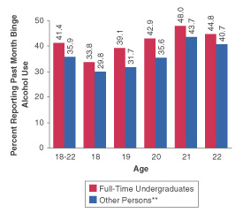
Graph #2 (Right)
Graph #1 (Left)
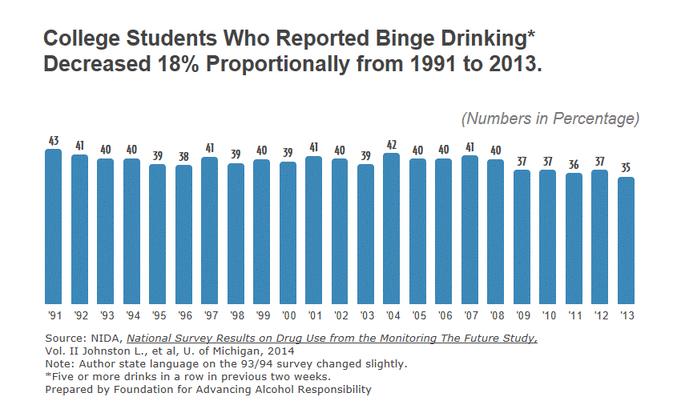

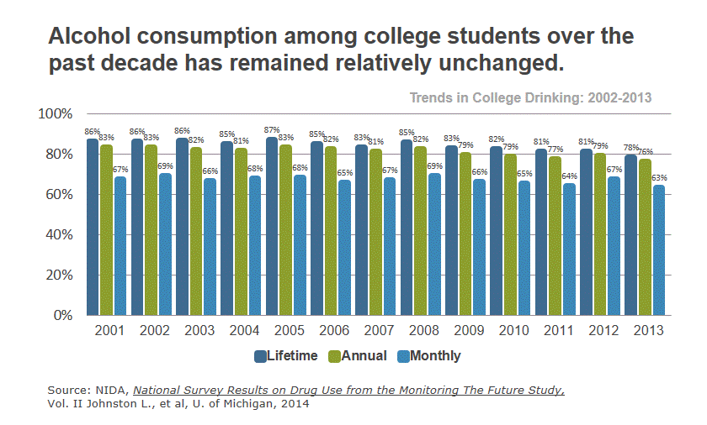
Graph #3 (left)

Information courtesy of (works cited):
Dowdall, George (W). College Drinking – Reframing a Social Problem. Westport, Connecticut. Praeger, 2009. Print.

Hingson, Ralph W., Wenxing Zha, and Elissa R. Weitzman. "Journal of Studies on Alcohol and Drugs." Trends in Alcohol Among U.S. College Students. N.p., 16 Sept. 2009. Web. 05 Oct. 2014.

Binge Drinking Statistics." Century Council. Foundation for Advancing Alcohol Responsibility, n.d. Web. 03 Oct. 2014. <http://responsibility.org/binge-drinking/statistics>

